Student Name: Shivam Kumar
Branch: CSE Semester: 6th
Experiment 10 (PROJECT)

UID: 23BCS14207
Section/Group: KRG 1B
Date of Performance: 06/04/2026



Subject Name: System Design Subject Code: 23CSH-314

1. Aim
To design and analyze a scalable real-time Airspace Defense Command Platform (Trinetra) that allows operators to monitor airspace, deploy aircraft and drone swarms, detect incoming threats, predict enemy trajectories, and coordinate interception missions efficiently using distributed system architecture, event streaming, and real-time communication technologies.

2. Objective
• To identify functional and non-functional requirements of an airspace defense system
• To design High Level Architecture (HLD) for a large-scale command and control platform
• To understand real-time telemetry streaming for aircraft and radar systems
• To design microservices for aircraft deployment, radar detection, mission planning, and combat simulation
• To understand AI-based threat prediction and interception mechanisms
• To study scalability challenges in large real-time simulation systems

3. Tools
• Draw.io / Excalidraw – System architecture diagrams
• PostgreSQL – Persistent storage for missions, assets, and event logs
• Redis – Caching real-time aircraft and threat positions
• Kafka – Event streaming for telemetry, radar detections, and combat events
• WebSockets – Real-time updates for the tactical dashboard
• Docker – Containerized deployment of microservices
• Load Balancer – Distribute incoming traffic across services
• Microservices Architecture – Modular distributed services
• Mapbox / Leaflet – Tactical airspace visualization
• AI Prediction Algorithms – Threat trajectory prediction

4. System Requirements
A. Functional Requirements
• Operators should be able to log in and access the command dashboard
• System should display real-time airspace map with aircraft, naval fleets, and threats
• Operators should be able to deploy aircraft, drone swarms, and naval fleets dynamically
• System should detect incoming enemy aircraft, drones, and missiles via radar simulation
• System should continuously track enemy movements and predict trajectories
• Operators should be able to assign interception missions to friendly aircraft
• System should support SAM Auto-Defense Zones that automatically destroy threats entering their range
• Aircraft must launch from the nearest airbase instead of spawning mid-air
• System should provide detailed metadata of each asset (speed, altitude, type, pilot info)
• Operators should be able to replay past events and analyze combat scenarios
• System should generate alerts for high-risk threats

B. Non-Functional Requirements
1) Scalability
a. Support 500–1000 simultaneous aircraft and threats
b. Handle continuous telemetry updates from multiple sources
2) Consistency
a. Mission assignments must be accurate and conflict-free
b. Prevent duplicate asset deployment or inconsistent mission states
3) Availability
a. Airspace monitoring dashboard must remain always operational
b. System must tolerate service failures without shutting down
4) Latency
a. Telemetry updates < 100 ms
b. Radar detection events < 150 ms
5) Reliability
a. No loss of simulation or mission data
b. Events must be durable through Kafka event logs

5. High Level Design (HLD)
The system follows Microservices Architecture.
Main Components

1) API Gateway
Responsibilities:
a. Authentication and authorization
b. Request routing to microservices
c. Rate limiting and traffic management
d. Centralized logging

2) Auth Service
Responsibilities:
a. User registration and login
b. Role-based access control
c. Token generation (JWT)
Database: PostgreSQL

3) Asset Management Service
Responsibilities:
a. Manage aircraft, drone swarms, naval fleets, and submarines
b. Track asset status and telemetry
c. Maintain asset metadata

4) Radar Detection Service
Responsibilities:
a. Simulate radar detection of enemy aircraft
b. Track incoming threats
c. Publish radar detection events to Kafka

5) Threat Analysis Service
Responsibilities:
a. Analyze enemy movement patterns
b. Calculate predicted trajectories
c. Assign threat priority levels

6) Simulation Engine
Responsibilities:
a. Continuously update positions of all aircraft and ships
b. Simulate movement physics and flight paths
c. Generate telemetry events
Telemetry events are sent to Kafka topics.

7) Mission Service
Responsibilities:
a. Assign fighter jets to intercept threats
b. Manage mission lifecycle
c. Update mission status

8) Combat Engine
Responsibilities:
a. Simulate missile launches and interceptions
b. Handle SAM defense zones
c. Determine combat outcomes

9) WebSocket Gateway
Responsibilities:
a. Push real-time updates to the frontend dashboard
b. Broadcast telemetry, mission updates, and combat events
Without WebSockets, the frontend would need to continuously poll the server.
With WebSockets:
• Aircraft positions update instantly
• Radar detections appear immediately
• Combat results are shown in real time

10) AI Prediction Service
Responsibilities:
a. Predict enemy trajectories
b. Estimate interception points
c. Rank threats based on danger level

6. Mission Execution Flow (Step-by-Step)
Operator logs into Trinetra command dashboard
System loads real-time airspace map
Radar Service detects incoming threat
Threat event published to Kafka topic
Threat Analysis Service predicts trajectory
Operator deploys fighter aircraft from nearest airbase
Mission Service assigns interception mission
Simulation Engine updates aircraft movement
Combat Engine simulates missile interception
WebSocket Gateway broadcasts results to UI
Dashboard updates with interception outcome

7. Scalability Solution
To support large-scale real-time simulations:
• Use Kafka for event streaming between services
• Use Redis to cache aircraft and threat positions
• Use WebSockets to push live updates to the UI
• Use Load Balancers to distribute incoming traffic
• Use Microservices architecture for modular scalability
• Use separate databases for users, missions, and logs
• Use Docker containers for scalable deployment
• Use airspace partitioning to distribute simulation workload
• Use AI prediction services to optimize mission decisions

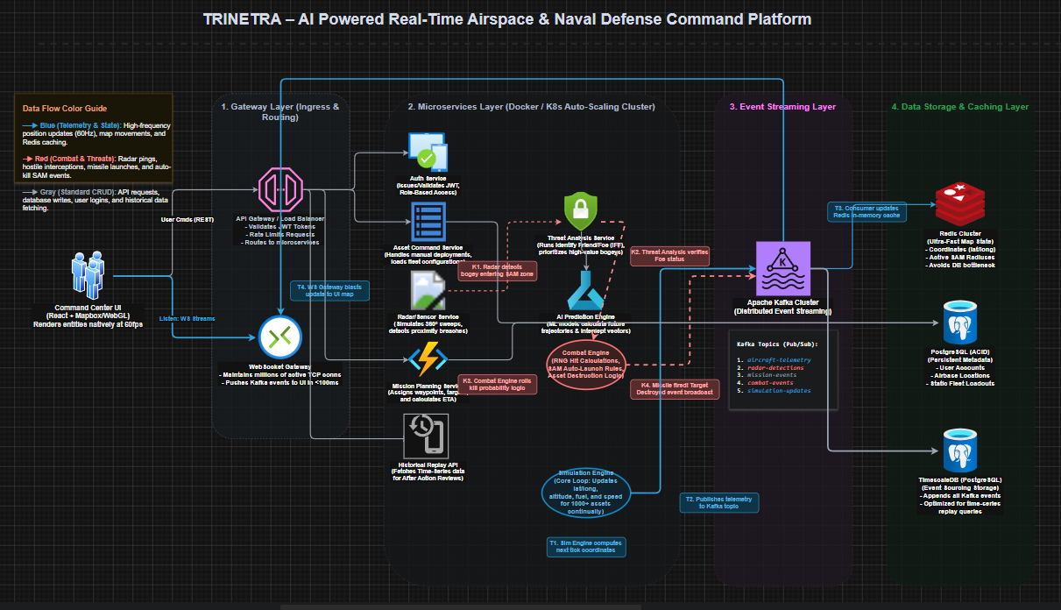

8. Learning Outcomes (What I Have Learnt)
• Learned how real-time command and control systems are designed
• Understood event streaming architecture using Kafka
• Learned how WebSockets enable real-time telemetry updates
• Understood AI-based threat prediction mechanisms
• Learned how microservices architecture supports scalability
• Understood how radar detection and interception systems work
• Learned about distributed simulation systems for large-scale environment

